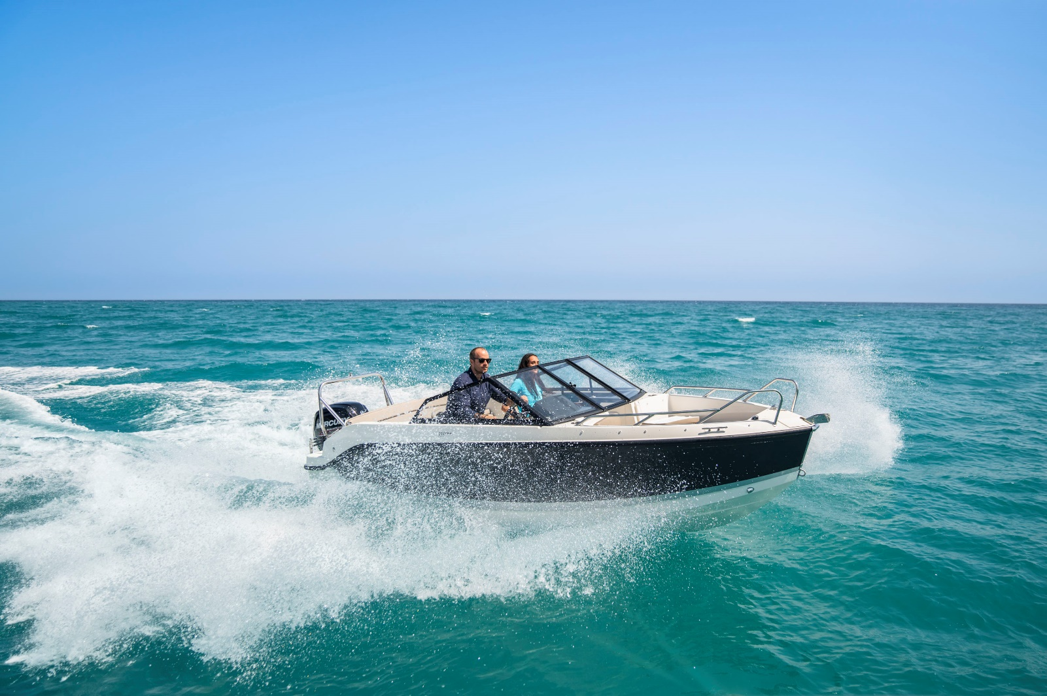

**Quicksilver Activ 555**

**Bowrider**

**Specifications: € 27.740,-**

Length: 5.33 m

Width: 2.17 m

Estimated draft: 0.36 m

Dry Weight: 934 kg

Fuel tank volume: 110 L

**This boat is standard equipped with the following options:**

Mercury F60 PK

Bow Roller

Swim Ladder

Navigation Lights

Forward Line/Anchor Locker

Self Bailing Cockpit

Swim Platforms

Motorwell Bridge

Bow Cushions

Analog Speedometer/Tachometer with Fuel & Trim Gauge

12v Electrical Socket

Aft Bench Seat

Storage below Aft Seat

Cockpit Cushions

Pilot Seat with Flip Bolster and Swivel

Co-pilot Seat

Single Battery System

Fire Extinguisher

Hydraulic Steering

Electric & Manual Bilge Pump

OB Pre-Rigging

VesselView Mobile

**Delivery Package**: Fire extinguisher, registration number, 4 fenders, 4 fender lines, 4 mooring lines, 50 liters of fuel.

**Engine Options:**

Mercury F60 CT **€ 730,-**

Mercury F80 **€ 2.960,-**

Mercury F100 **€ 4.770,-**

Mercury F100 CT **€ 5.760,-**

Mercury F115 **€ 5.720,-**

Mercury F115 CT **€ 6.750,-**

**Options & Accessories:**

Freight **€ 1820,-**

Ski Tow Bar **€ 890,-**

Flexiteek Flooring **€ 2.630,-**

Hull Color (Dark Grey) **€ 740,-**

SmartCraft Speedometer/Tachometer **€ 860,-**

Active Trim **€ 860,-**

DAB Stereo Kit with Antenna **€ 280,-**

Stereo Fusion with 2 Speakers **€ 860,-**

Cockpit Sun Lounge **€ 770,-**

Cockpit Table with Laminated Top **€ 300,-**

Mooring Kit **€ 350,-**

Starboard Windscreen Wiper **€ 300,-**

Bimini **€ 1.450.,-**

Refrigerator **€ 1.390,-**

SMART Edition* **€ 3.170,-**

Electronics Pack** **€ 2.160,-**

**Canvas options:**

Bimini with Enclosed Canvas **€ 2.270,-**

Enclosure for bimini with Smart Edition **€ 830,-**

Mooring Cover **€ 950,-**

* Forward Sun Lounge, Cockpit Sun Lounge, Cockpit Table With Laminated Top, Bimini, Bow Walkthrough Door

** Stereo Fusion With 2 Speakers, Simrad Gps/Chart Plotter Cruise 7 With Hdi Transducer