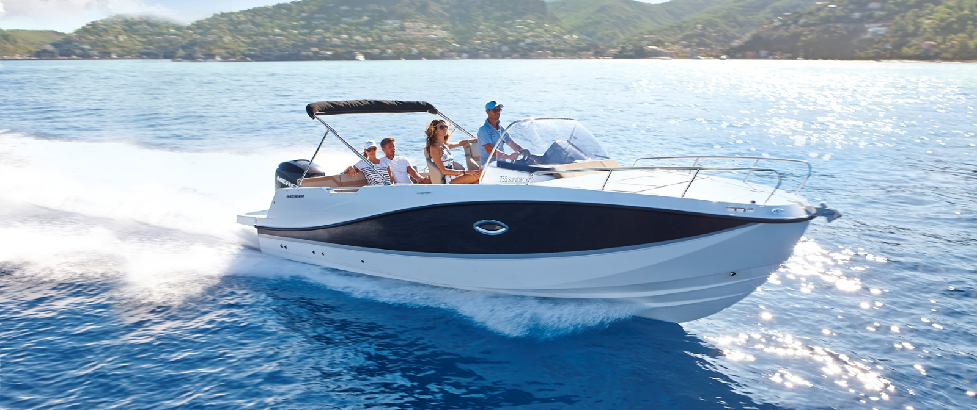
Quicksilver Activ 755
Sundeck

Specifications: € 60.670,-
Length: 7.23 m
Width: 2.55 m
Estimated draft: 0.55 m
Dry Weight: 1.683 kg
Fuel tank volume: 280 L

This boat is standard equipped with the following options:

Mercury F175 PK
Bow Roller
Swim Ladder
Navigation Lights
Forward Line/Anchor Locker
Self Bailing Cockpit
LED Courtesy Lights
Swim Platforms
Forward Sun Lounge
SmartCraft Speedometer/Tachometer
12v Electrical Socket
Adjustable Steering Position
Active Trim
Pilot Seat with Flip Bolster and Swivel
Co-pilot Seat
Aft Seat Extension L-Lounge
Upgraded Cockpit Table
Cockpit Cushions
Aft Bench Seat
Storage below Aft Seat
2 berths
Dinette Seat Configuration
Cabin Lights
Opening Portlights
Deck Hatch - Opening
Storage below Berth
Single Battery System
Hydraulic Steering
Electric & Manual Bilge Pump
OB Pre-Rigging
CO Monitor
Fire Extinguisher
VesselView Mobile

Delivery Package: Fire extinguisher, registration number, 4 fenders, 4 fender lines, 4 mooring lines, 50 liters of fuel.

Engine Options:
Mercury F200 V6 € 540,-
Mercury F225 V6 € 2.090,-
Mercury F250 V8 Verado € 7.030,-
Mercury F300 V8 Verado € 12.910,-

Options & Accessories:
Freight € 3.250,-
Flexiteek Flooring € 3.740,-
Swim Platform Extensions with Flexiteek € 1.140,-
Swim Platform Extensions € 880,-
Swim Platform Extensions with Motor Bracket € 880,-
Swim Platform Extensions with Flexiteek & Motor Bracket € 1.140,-
Hull Color (Dark Grey) € 1.210,-
Ski Pole € 880,-
Stereo Fusion with 4 speakers € 860,-
Simrad GPS/Chart Plotter 7" NSS Evo3s with HDI Transducer € 1.810,-
VesselView Link Digital Interface € 680,-
DAB Stereo Kit with Antenna € 280,-
Leaning Post € 350,-
Port Flip Seat € 1.330,-
Real Teak Cockpit Table € 1.200,-
Cockpit Shower € 790,-
Sea Toilet € 2.110,-
Grey Water System with Dock Discharge (80L) € 440,-
Bow Electrical Windlass € 2.520,-
Motor Bracket € 340,-
Electric Trim Tabs € 1.820,-
Mooring Kit € 590,-
Fully equipped galley*** € 4.330,-
Forward Sun Awning € 1.040,-
Bimini € 1.530,-
SMART Edition** € 8.560,-
Cabin Comfort Pack* € 860,-

Canvas options:
Bimini with Enclosed Canvas (with Smart Edition) € 1.170,-
Bimini with Enclosed Canvas € 2.640,-
Transport Cover € 2.620,-
Console & Bolster Seats Cover € 550,-
Console & Leaning Post Cover € 790,-

* Curtains, Cabin Table, Berth Cushions/Filler, Interior Side Bolster

** Bimini, Stereo Fusion With 4 Speakers, Port Flip Seat, Real Teak Cockpit Table, Bow Electrical Windlass, Motorwell Bridge, Curtains, Cabin Table, Berth Cushions/Filler, Mooring Kit, Interior Side Bolster

*** Sink With Tap, Stove Lpg, Refrigerator, Cockpit Shower

