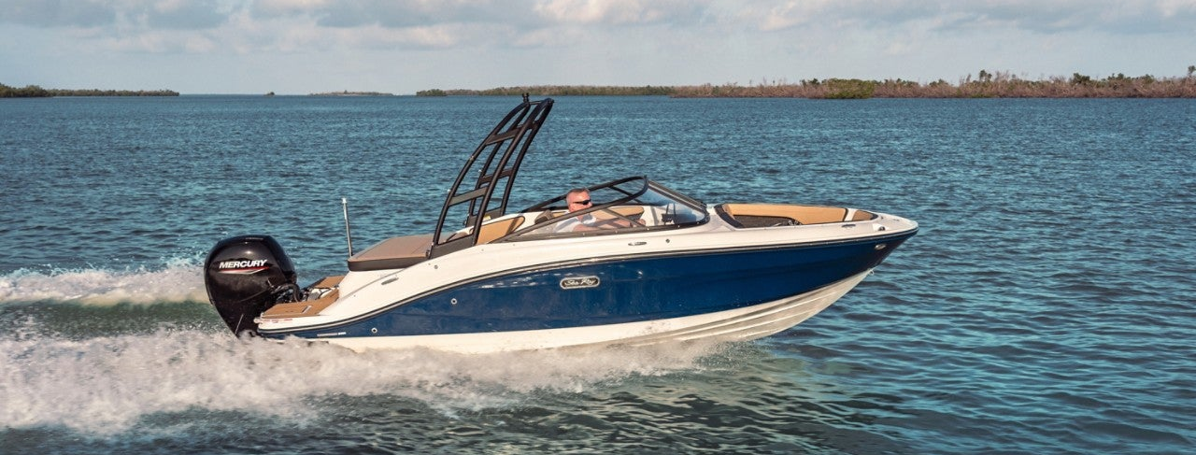

Sea Ray SPX 190 Outboard

Specifications: € 59.450,-
Length: 6.65 m
Width: 2.54 m
Estimated draft: 0.81 m
Dry Weight: 1.490 kg
Fuel tank volume: 110 L

This boat is standard equipped with the following options:
Mercury F115 ELPT
White Gelcoat Hull and Deck
Hull Side Color Selections (Black/ Sea Ray Blue/ Ocean Blue/ Rally Red/ Steel Gray/ Mojave Tan)
Full Color Hull Selections (Black/ Sea Ray Blue/ Ocean Blue/ Rally Red/ Steel Gray/ Mojave Tan)
Hull Bottom (White or Black)
Cockpit upholstery: Ivory (STD) / Dune / Stone
Stainless Steel Package (SST Rubrail Insert, SST Handrails & SST Cup Holders)
Bluetooth Radio With USB Input
Depth Finder
Battery On/Off Switch
CE Option
CE Approved Fire Suppression System - Automatic

Delivery Package: Fire extinguisher, registration number, 4 fenders, 4 fender lines, 4 mooring lines, 50 liters of fuel.

Engine Options:
Mercury F115 ELPT
€ 3.510,-
Options & Accessories:
Gel Stripe (Black/ Sea Ray Blue/ Rally Red/ Steel Gray, Kingfisher Teal) € 690,-
Captains Package* € 3.805,-
Infinity, Woven Cockpit Flooring € 1.385,-
SeaDek covering on Swim platform (Gray or Mocha) € 690,-
SeaDek Cockpit glued in € 1.730,-
Black Watersport Tower with Bimini-top € 5.710,-
LED Lighting – Blue / white € 1.040,-
Transom Shower € 865,-
Digital Dash NSX 3012 UltraWide € 3.460,-
Premier Stereo with extra speakers & Subwoofer € 2.595,-
Ski Tow Pylon € 520,-
Mooring Cover € 1.385,- Canvas Enclosure Package € 1.555,-

* Bimini-top w/Boot, Stainless Steel Bal & Socket Hardware - Bow Filler Cushion with forward Walk-Thru Backrest cushion - Canvas, Cockpit and Tonneau Cover - Cockpit Table, Teak – Fender Clips.

