
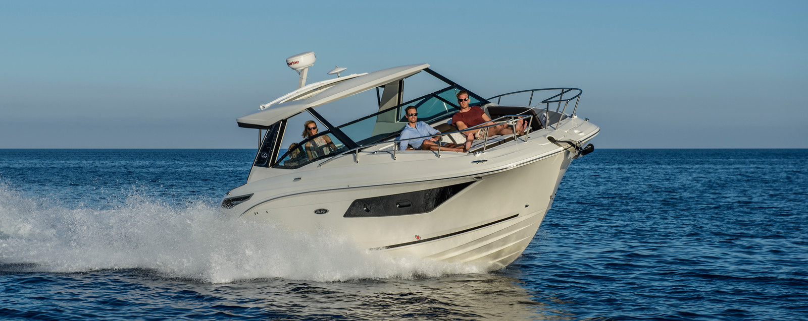Sea Ray Sundancer 320

Specifications: € 353.700,-
Length: 9.82 m
Width: 3.25 m
Estimated draft: 1.02 m
Dry Weight: 6.035 kg
Fuel tank volume: 643 L

This boat is standard equipped with the following options:

T-Mercruiser ECT 6.2L V8 MPI DTS Bravo® III (300 PK)
White Gelcoat Hull and Deck
Hull Bottom (White or Black)
Hull Side Color Selections
(Black/ Sea Ray Blue/ Ocean Blue/ Rally Red/ Steel Gray/ Mojave Tan)
Full Color Hull Selections
(Black/ Sea Ray Blue/ Ocean Blue/ Rally Red/ Steel Gray/ Mojave Tan)
Cockpit upholstery: Ivory (STD) / Dune / Stone
Wood Interior – Walnut (STD) / Driftwood
Hardtop, Fiberglass
Stainless Steel Package
Teak Cockpit Table
Microwave - 220v/50
Toilet - Electric with holding tank and Macerator
Dual Digital Dash w/ Mercury Vesselview Link (9")
Flooring - Snap in Carpet
Bluetooth Radio With USB Input
Battery Charger
220 Volt / 50 cycle Electrical System
Shore Power Package w/ Converter & Cord - 220V/50
Depth Finder
Battery On/Off Switch
CE Option
CE Approved Fire Suppression System – Automatic

Delivery Package: Fire extinguisher, registration number, 4 fenders, 4 fender lines, 4 mooring lines, 50 liters of fuel.

Engine Options:
T-Mercruiser ECT 6.2L (350 PK) MPI AXIUS Bravo® III-X € 46.560,-

Options & Accessories:
Windshield defroster € 1.765,-
Bow Thruster € 4.365,-
Captain’s package € 3.595,-
Windlass - Electric with Chain & stainless Steel Anchor € 4.260,-
Coupe Enclosure € 23.355,-
Adjustable V-Berth Table Support € 1.595,-
Teak Decking, Swim platform € 3.015,-
Teak Flooring – Cockpit € 5.505,-
Grill-Cockpit-Built In-220V/50 € 2.170,-
Led Package in Cockpit - Blue or white € 2.450,-
Refrigerator (12 volt) in Cockpit € 2.415,-
Automated Submersible Swim Platform € 11.780,-
Portlight - Opening - 1 Galley & Salon Area € 665,-
T.V. - Flat Screen w/ DVD - Salon - 220v/50 € 1.285,-
Dual Digital Dash w/ Mercury Vesselview Link (12")NSX € 6.965,-
Air Conditioning / Heating, Cabin and Cockpit - 220V/50 € 11.350,-
Spotlight - 5 Remote Controlled € 1.125,-
Transom Sunpad seating € 2.735,-
Generator - Gas - 220v/50HZ € 27.650,-
Macerator with Seacock Interlock € 900,-

Canvas options:

Canvas package Hard Top € 5.025,-

* Bimini-top w/Boot, Stainless Steel Bal & Socket Hardware - Canvas, Cockpit and Tonneau Cover – Bow Filler Cushion with forward Walk-thru Backrest cushion - Transom Shower - Docking Lights - Windshield Wiper Starboard – Bow Washdown – Flagpole – Fender Clips.

Totaal: €524.230,-

